Technical Design for Toon Lines

Revision History

Issue | Date | Person | Reason
0.1 | March 5, 2002 | Darryl Long | Created
1.0 | April 12, 2002 | Darryl Long | Reviewed by team and released

Description

Introduction
The Toon Line component displays black lines around the edges of geometry to give the appearance of cartoon lines.

Several methods for displaying these lines have been investigated. The preferred method is to have an extra set of geometry around the model, coloured black and drawn first. However, the artists have complained about maintaining the extra set of geometry. It is suggested we stay away from having the artists generate the toon line geometry and move this operation into the pipeline.

Skinned geometry present another problem, so we have cut support for Toon Lined, skinned objects. However, we will need to support toon lines on vehicles, which will have flapping doors, hoods, and will deform after collisions.

Requirements
- Must be fast -- use buffered geometry
- Minimize artist’s workflow using a naming convention to mark a piece of geometry for Toon Lines
- Pipeline tool to add Toon Line geometry to marked objects
- Toon Lines for vehicles
- Toon Lines for landmark buildings
- Code to render the Toon Line geometry immediately before the main geometry
- Code to animate the Toon Lines along with moving physics objects (in the case of the car)

References
- Talked to Yayoi about where she wants toon lines
- Talk to Greg about how cars will be animated
- Talked to Yayoi about the problems with artists creating toon lines

Technical Design

Relationships
World Objects that need toon lines displayed around them have a reference to a toon line geometry object. The toon line rendering depends on Pure3D for primgroups.

The toon lines need their own chunk type so they can be loaded quickly. The toon line chunk is a subchunk of the SimpsonsGeometryChunk.

The toon lines need their own shader and reversed normals, and these should be computer in the pipeline.

Interface

ToonLineGeometry : public tGeometry
{
public:
virtual void Render();
};

class ToonLineGeometryLoader : public tSimpleChunkHandler
{
public:
ToonLineGeometryLoader();
protected:
virtual tEntity* LoadObject(tChunkFile*, tEntityStore* store);
virtual SimpsonGeometry* Allocate(int nPrimGroup, bool shadow);
};

A SimpsonsGeometry object has a reference to a ToonLineGeometry object which is created via the ToonLineGeometryLoader.

Component Class Diagrams

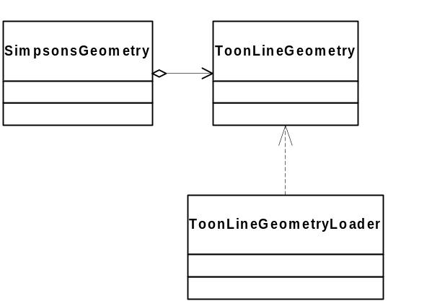

Use Cases

